1.Question 1

Consider the following presentation assessment from an undergraduate business unit of study outline.

*Groups of 3-4 will design an online marketing campaign for the organisation of their choice. They will write a report addressed to the organisation’s marketing director, giving reasons for their choices. Groups will also present their campaign in the final lesson of the course. The presentation must be addressed to the company’s board of directors, and will need to ‘pitch’ their marketing strategy to the board, as well as giving reasons for their choices. The presentation will last for 10 minutes, with extra time at the end for questions.*

Who is/are your audience/audiences for this presentation?

A. Students

B. Academics

D. Imaginary board of directors

(chọn) A, B and D

2.Question 2

Consider the same presentation assessment from an undergraduate business course unit of study outline.

*Groups of 3-4 will design an online marketing campaign for the organisation of their choice. They will write a report addressed to the organisation’s marketing director, giving reasons for their choices. Groups will also present their campaign in the final lesson of the course. The presentation must be addressed to the company’s board of directors, and will need to ‘pitch’ their marketing strategy to the board, as well as giving reasons for their choices. The presentation will last for 10 minutes, with extra time at the end for questions.*

What kind of research will students need to do for the *presentation*?

A. None

3.Question 3

Consider the same presentation assessment from an undergraduate business course unit of study outline.

*Groups of 3-4 will design an online marketing campaign for the organisation of their choice. They will write a report addressed to the organisation’s marketing director, giving reasons for their choices. Groups will also present their campaign in the final lesson of the course. The presentation must be addressed to the company’s board of directors, and will need to ‘pitch’ their marketing strategy to the board, as well as giving reasons for their choices. The presentation will last for 10 minutes, with extra time at the end for questions.*

What will be the best structure for the body of this presentation?

General to Specific.

4.Question 4

Consider the same presentation assessment from an undergraduate business course unit of study outline.

*Groups of 3-4 will design an online marketing campaign for the organisation of their choice. They will write a report addressed to the organisation’s marketing director, giving reasons for their choices. Groups will also present their campaign in the final lesson of the course. The presentation must be addressed to the company’s board of directors, and will need to ‘pitch’ their marketing strategy to the board, as well as giving reasons for their choices. The presentation will last for 10 minutes, with extra time at the end for questions.*

Your group member would like to give the following introduction to the talk.

*‘Good afternoon everyone. Today’s presentation will outline our proposed online marketing plan for XYZ industries. Our presentation will firstly give the theoretical background for our proposed plan. We will then present information on the demographics we will be targeting, and following that the channels and schedules for the online market plan. We would ask you to please save any questions until the end.’*

What do you think of the introduction?

It’s missing an outline of what each presenter will be talking about.

5.Question 5

Consider the same presentation assessment from an undergraduate business course unit of study outline.

*Groups of 3-4 will design an online marketing campaign for the organisation of their choice. They will write a report addressed to the organisation’s marketing director, giving reasons for their choices. Groups will also present their campaign in the final lesson of the course. The presentation must be addressed to the company’s board of directors, and will need to ‘pitch’ their marketing strategy to the board, as well as giving reasons for their choices. The presentation will last for 10 minutes, with extra time at the end for questions.*

Here is an information graphic one of your group members wants to present in the presentation.

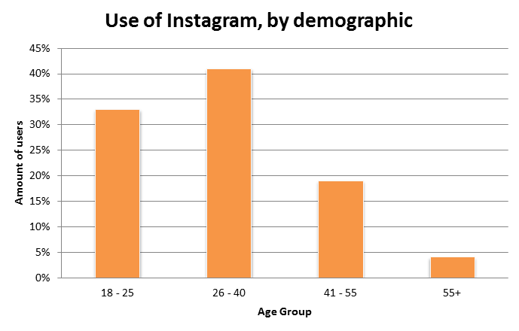

What do you think of this information graphic?

It’s fine.

6.Question 6

Consider the same presentation assessment from an undergraduate business course unit of study outline.

*Groups of 3-4 will design an online marketing campaign for the organisation of their choice. They will write a report addressed to the organisation’s marketing director, giving reasons for their choices. Groups will also present their campaign in the final lesson of the course. The presentation must be addressed to the company’s board of directors, and will need to ‘pitch’ their marketing strategy to the board, as well as giving reasons for their choices. The presentation will last for 10 minutes, with extra time at the end for questions.*

One of your group members would like to write out the full script for the presentation. What are two of the drawbacks with this approach?

It will limit your ability to adapt the presentation to different situations.

Reading off a piece of paper will cause your audience to disengage.

7.Question 7

Consider the same presentation assessment from an undergraduate business course unit of study outline.

*Groups of 3-4 will design an online marketing campaign for the organisation of their choice. They will write a report addressed to the organisation’s marketing director, giving reasons for their choices. Groups will also present their campaign in the final lesson of the course. The presentation must be addressed to the company’s board of directors, and will need to ‘pitch’ their marketing strategy to the board, as well as giving reasons for their choices. The presentation will last for 10 minutes, with extra time at the end for questions.*

You have started delivering your presentation but you have noticed that the audience seem disengaged, and are not paying attention. What do you do?

Make eye contact.

Smile and stand taller.

8.Question 8

Consider the same presentation assessment from an undergraduate business course unit of study outline.

*Groups of 3-4 will design an online marketing campaign for the organisation of their choice. They will write a report addressed to the organisation’s marketing director, giving reasons for their choices. Groups will also present their campaign in the final lesson of the course. The presentation must be addressed to the company’s board of directors, and will need to ‘pitch’ their marketing strategy to the board, as well as giving reasons for their choices. The presentation will last for 10 minutes, with extra time at the end for questions.*

Someone asks a difficult question at the end, criticising part of your online marketing campaign aimed at students and saying that students use different kinds of online media. What is a suitable reply?

“That’s a valid point. However according to Smith and Jones (2015) students …”

“That’s an interesting point. What are other people’s views? Do you think, as students, you would respond to this campaign?”